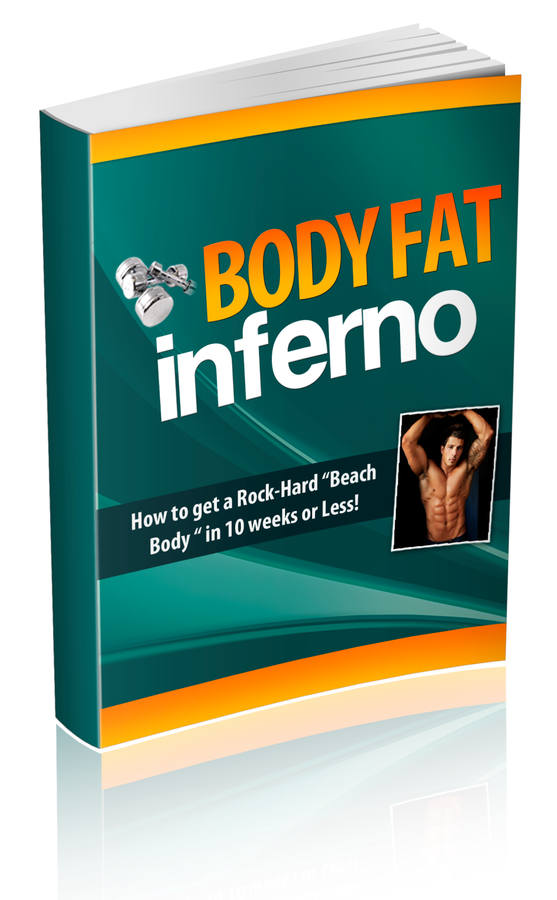
Copyright Notice

This information is for your personal use ONLY. You cannot distribute, copy, reproduce, or otherwise sell this product or information in any form whatsoever, including but not limited to: electronic, or mechanical, including photocopying, recording, or by any informational storage or retrieval system without expressed written, dated and signed permission from the author. All copyrights are reserved.

Disclaimer and/or Legal Notices

First of all, I’m not a doctor so the information contained in this product is by no means meant to be taken as medical advice. Furthermore, the information provided in this book is for educational purposes only.

The information presented to you in this book is based off of the personal experiences of the author(s), as well as from current research and data.

The advice and tips given in this course are meant for healthy adults only. Before performing anything stated in this product, you should consult your physician to ensure the information provided is appropriate for your individual circumstances.

If you have any health issues or pre-existing conditions, please consult with your physician before implementing any of the information provided in this course.

This product is for informational purposes only and the author does not accept any responsibilities for any liabilities or damages, real or perceived, resulting from the use of this information.

Contents

Introduction - A New Goal: 25 Pounds In 10 Weeks 4
Part 1 - The Workout Plan: The Only 30-Minute Workout You Need 5
Monday Routine: 6
Tuesday Routine: 7
Wednesday & Friday Routine: 7
Thursday & Saturday Routine: 8
Abs Routine: 8
Alternate Exercises: 9
Part 2 - The Diet Guide: How to Drop Body Fat Without Starving Yourself 10
Smoothie Recipes: 11
Breakfast Meal 12
Post-Workout Meal 13
Part 3 - Supplement Guide: What to Buy and What’s a Waste of Money 15
Final Thoughts - The End of the Beginning 17
One Last Thing... 18

Introduction:

A New Goal - 25 Pounds In 10 Weeks

One day at the end of 2012, I woke up and decided I wanted to enlist in the United States Air Force. This felt like a great choice, however, there was only one problem--I had to drop close to 25 pounds as fast as possible.

For a normal person to lose 20 pounds, it could take several months. Being the go getter that I am, I had it all planned out to lose that weight in about 10 weeks.

I have always been pretty knowledgeable on fitness and what not, but before I started my challenge, I was kind of lost on the most effective way to lose weight fast.

My whole life I had lifted weights and done cardio, but never had I attempted something like this. I knew I had to do a different workout routine and cardio routine, change my diet, and also change my lifestyle around.

Every time I lifted weights before, I always lifted with a bodybuilders mindset. I would lift one or two major muscle groups per day, 5 days a week. I would do the same exercises for months at a time. My repetitions and sets never changed, only the weight I was lifting increased.

The cardio routines I did were always the same no matter what piece of equipment I was on. Looking back, I really robbed myself of my true potential since I didn't know anything about what I'm going to discuss in this product.

It was right before I wanted to start my challenge that I was introduced to Cross Fit style workouts - or "High Intensity Interval Training".

This type of working out was designed to give different muscle groups stimulation, while going at a high intensity to burn more calories than normal.

I did tons of research online to learn the exercises and workout routines, then I went ahead and tried it out.

I could tell right away after my first workout that this was going to be what I needed.

I felt more burnt out after this workout than I did between 2 hours of weights and 30 minutes of cardio. The best part about it was the workout only took 25 minutes to complete.

From that day forward, I did that workout, and an additional cardio workout, for 6 days a week. 10 weeks later, I had lost over 20 pounds and 8% body fat, all while becoming stronger from my workouts, and healthier because of my diet.

Part 1: The Workout Plan

The Only 30-Minute Workout You Need

I usually arrive to the gym around 11am, which is great since it is not too overly crowded at that time. My gym is perfect for these workouts because all of the equipment needed is right next to each other.

I always start off stretching to get your muscles warmed up and to get some blood flowing.

Do several minutes of stretching your main muscle groups- chest, back, arms, and legs. I usually would stretch for 10 minutes just to make sure I hit the areas good enough. After that, we are ready to go!

Below is a breakdown of each day in workout, complete with both the exercise and the set/rep scheme. If you’re unfamiliar with any of these exercises, BodyBuilding.com/exercises has an entire video tutorial library so you can actually see the exercise to make sure you’re doing it right.

Note: there are a few main routines and you then repeat those routines during other days of the week.

Monday Routine:

Repeat this series in this order for 5 continuous rounds:
- 500m Row
- 10 burpees
- 10 kettle ball swings
- 7 pull-ups
- 10 dips

When you are using the rowing machine, you want to focus on really squeezing your back together when you pull the handles back. However, you want to make sure you are using a smooth, fluid motion. Depending on how fast you can row, the 500m shouldn't take you more than a few minutes.

After that, go straight to burpees. Burpees are awesome for your entire body. I think this was the hardest part of the circuit for me, I just loved the feeling from doing these.

It is up to you how much weight to use with the kettle ball swings. My gym didn't have kettle balls, so I had to make due with a dumbbell. Essentially you get the same motion, but it is harder to grip the dumbbell.

After that, I get over to the pull up bar as fast as possible and crank out the 7 wide grip pull ups. If pull ups are hard for you, chin ups might be a little easier. I really focus on squeezing my back together at the top of the pull up so that I can engage my lats as much as possible.

The dips are good for your chest and triceps. Once you are done with round 1 of the circuit, get right back to the rowing machine and repeat the whole process. I keep a towel and water bottle next to the rowing machine so I can grab it before I start the next round.

Also, you will find that rowing allows you to catch your breath, sort of like a rest period between the other exercises (while still being a tough workout and engaging your entire body).

I definitely would recommend timing yourself on how long it takes to complete 5 full rounds of Monday's circuit. The whole point of interval training is to do the exercises as fast as possible, so keeping track of the time allows you to push yourself to get better times on the circuit.

Tuesday Routine:

Do 5 rounds of this circuit with 2 minutes in between each round:
- 10 barbell squats
- 15 calf raises
- 10 dumbbell lunges
- 10 DB stiff legged dead lifts

This is a very hard circuit to do continuously which is why I rest in between rounds. Your legs will definitely get stronger fast with this rotation.

I like to really focus on going below parallel with the squats, even though I'm not using as much weight.

Once you are done with the squats, keep the bar on your shoulders and go straight to calf raises. The goal is to stand as high as possible on your tip toes, really squeezing out your calf muscles.

I keep the dumb bells right next to the squat rack so I can transition quickly into the lunges and stiff legged dead lifts. For the lunges, I have one dumb bell in each hand and go down one leg at a time. You want to focus on keeping constant tension in the back in your hamstrings and butt.

After my 5 rounds are complete, I always do an extremely thorough stretching section, focusing on my legs and core muscles. This is very important so you can allow as much blood into your muscles as possible.

Wednesday & Friday Routine:
Same as Monday

Thursday & Saturday Routine:
Same as Tuesday

Abs Routine:

I do an abdominal circuit every Monday, Wednesday, and Friday - in addition to the other circuit on that day. This usually doesn't take too long to do (only 15 minutes or so).

My abdominal routine consists of:

- Hanging leg raises (3 sets of 12 reps)
- V-Sits (3 sets of 20 reps)
- Flutter Kicks (3 sets of 1-min kicks)
- Planks (3 sets of 1-min planks)
- Side planks (4 sets of 30-second side planks on each side)

Do all sets for each one of these exercises in order. This abs routine isn’t meant to be done like the other routines. It’s meant to be done one exercise at a time (for all the sets and reps indicated) before moving on to the next exercise.

Do all sets for each one of these exercises in order. This isn’t a “circuit”; it’s meant to be done one exercise at a time (for all the sets and reps indicated).

I like to do the hanging leg raises first. You get on the pull up bar, arms hanging straight down, and then bring your knees to your up to your chest, side by side, so that you focus on your oblique's mainly. I do 3 sets of 12 for this.

Then I go straight to the V Sits for 3 sets of 20. By now you are feeling pretty good in the midsection.

Then I go straight to the ground with 3 sets of 1 minute flutter kicks. After those, I end the workout with 3 sets of 1 minute planks and 4 sets for 30 seconds of side planks (2 on each side).

This is a great, all around abs workout which I do 3 days a week (Monday, Wednesday, and Friday).

Alternate Exercises:

There are tons of variations to many of the exercises in this program. That’s a good thing too, since it gives you more flexibility in your routines and prevents you from hitting plateaus in your workout.

I wanted to give you a few examples of how you can vary specific exercises by alternating them in or out with some other variations:

- Pull ups can be subbed for chin ups.
The difference is that with pull ups, your palms are facing away from you, which is why they engage your back more. Chin ups are where your palms are facing you, which is why they engage your biceps more.

- Inverted Rows are excellent to engage your back and core.
This is easiest to do on the squat rack. Set the barbell about 3-4 feet above the ground, and position a bench so your heels can rest on it laying stretched out parallel to the ground directly below the barbell. Place your hands on the barbell shoulder-width apart and pull yourself up, keeping your body straight and rigid. This exercise will engage the back and core extremely well.

- Kettle bell swings can be done with 2 hands, or single-handed, 1 arm at a time.
As I said before, my gym doesn't have kettle bells specifically so I have to use dumbbells, but the same principles apply. I would recommend single-handed kettle bell swings as isometric exercises will burn more calories (that's when you do one side at a time instead of working both sides at once as with a 2-handed swing).

- Push ups can be done instead of burpees.
Regular push ups, wide grip push ups, close grip "diamond" push ups, finger tip push ups, or clap push ups are all options. The variations I just listed get harder to perform, but as your level of fitness increases, try mixing these up for a tougher workout.

- Hand stand push ups with your legs against the wall.
These are very tough since you're essentially pushing up your entire body's weight. Needless to say, this is an advanced workout that's definitely something to strive for.

- Pull ups can be subbed for muscle ups.
This is another advanced exercise that will engage more muscles more extensively, but it's not easy. For muscle ups, start with a pull up, but when you get to the top of the pull up, you actually rotate your grip on the bar and push yourself up (like you're doing a dip) above the bar. Lower yourself down again through the dip and then down through the pull up. That's one rep.

- Tuck jumps are great for leg day.
These are where you jump and "tuck" your legs into your chest at the top of the jump.

Part 2: The Diet Guide

How to Drop Body Fat Without Starving Yourself

I need to explain something about this dieting guide before we get into everything...

If you’re in a crunch and you want (or need) to lose weight or body fat FAST, then you’re not going to find a diet that you enjoy that lets you slam cheeseburgers and fries.

If you want that kind of diet, this isn’t for you.

This diet is meant to get results, and it’s extremely effective at doing that. That’s not to say it’s super hard to do or that you’ll be starving all day, because you won’t.

Quite the opposite: if you follow it like I lay out, you’ll feel satiated throughout the day and won’t have that hungry feeling knowing at you all day.

But think about it like this as well:

If you stick to this plan for 10 weeks (maybe a few weeks more depending on where you’re starting at), then you’ll drop the pounds and body fat and you’ll be able to stabilize your diet.

This isn’t a permanent thing, so don’t think you’ll never have a beer or burger again. Remember that.

This is ONLY for a specific “cutting period” where our primary goal is to subtract body fat through rigorous workouts and a calorie-deficiency-based nutrition plan.

With that said, let me break down the mechanics of the Diet Guide...

I really wanted to limit the amount of physical hard food that I ate, so I decided to have a diet that consisted mostly of liquid – using smoothies.

Smoothies are excellent to have since you can get all the fruits and vegetables you need in a day, all without tasting bad at all. I personally don’t like spinach, but you won’t taste any spinach at all in a smoothie – even using 3-4 cups like I do.

Smoothie Recipes:

Tropical Thunder:
- 2/3 cup – almond milk
- 2 cups – kale
- 2 cups – spinach
- 1-1½ cups – pineapple
- ½ banana
- 1 Tbsp – ginger root
- 2 handfuls of ice

Blend all these in a blender (I have a Ninja that works like a champ) for about 10-15 seconds.

Peanut Butter Banana Bliss:
- 2/3 cup – almond milk
- 2 cups – kale
- 2 cups – spinach
- 2 Tbsp – natural peanut butter (the kind with the oil separation at the top; I prefer Skippy’s Natural Chunky Peanut Butter)
- ½ banana
- 2 handfuls of ice

Blend all these in a blender for about 10-15 seconds.

Both of these make for pretty decent-tasting smoothies, all while giving me exactly what I need to lose weight and feel great. I make a total of 3 smoothies per day: in the morning, in the evening for dinner, and then before bed time.

If you use the first recipe after working out, add 1 scoop of Vanilla Whey Protein (preferably a protein isolate) to speed up muscle recovery. I talk about that more in the Supplement section next, though.

For my dieting period, I recommend eating only one "whole meal" a day, which should always be in the mid-afternoon after working out.

But, that doesn’t mean you can’t have substantial meals, though... They’re very different. I consider a “whole mean” as being one that I have to cook, that I can’t microwave or heat up fast.

Breakfast Meal

I always like to start each day with 1-2 cups of coffee. I can’t stand black coffee, so I added a little cream (I use ‘Half and Half’; I think milk sucks in coffee).

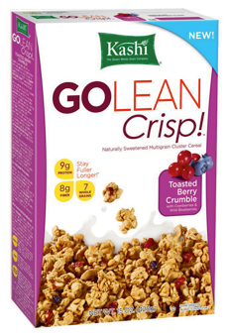
After the coffee, I’d usually have a bowl of whole grain oatmeal or cereal for breakfast.

I actually really like Kashi’s GoLean Crisp Toasted Berry Crumble pictured on the right. They have an awesome Cinnamon version of this cereal as well, and both pack protein and nutrition for your breakfast meal.

Again – I don’t count this as a whole meal since I don’t have to “cook” it.

Post-Workout Meal

After working out, I would always make 5 eggs (5 egg whites with only 2 yolks) mixed in the skillet with fresh cut mushrooms, green peppers, poblano peppers, and black beans.

I use different spices to bring out the flavors, mostly different variations of red pepper, black pepper, and cayenne pepper.

This isn’t a skillet recipe you HAVE to follow, of course. Just make sure you put “clean” foods in your skillet.

Some other ingredients you can add are:

- Any vegetables (I just prefer mushrooms and peppers)
- Any spices
- Any sauces (in moderation, of course – stick to a serving size, which is usually only 1 tablespoon)
- Lean protein (chicken, turkey, white fish, extra lean ground beef)
- Tofu
- Meatless Ground (a vegetarian “meat” product that actually does make things taste good)

I like starting with 5 eggs (5 whites and 2 yolks), but with all the variations of skillets you can make here, you should never get bored.

I recommend buying a non-stick pan to cook this in. You’ll thank me later, and cooking a skillet every single day you’ll more than get your money’s worth very quickly. The clean up time is worth it alone!


Along with the egg skillet, I eat one cup of oatmeal (like the Quaker Oats pictured on the left) mixed with brown sugar and cinnamon.

This meal will really fill you up and it’s super clean so your body digests/breaks it down perfectly.

Other than that, I made sure to consume THREE smoothies every day and take a few different supplements (we'll talk about those in the next section).

As you can see, this isn't a crazy strict diet.

The foods you'll eat need to be "clean", but with spices you have all kinds of variations on flavor so things won't ever get old.

The smoothies do help fill you up during the day and provide nutrition you wouldn’t otherwise be getting. For example, I went from not having ANY spinach and greens (like kale) to having 6-12 cups per day.

And best of all… I don’t taste any of it :)

You don't need to focus on calories either.

You'll get plenty of nutrients and all the vitamins without worrying over counting every little calorie.

Also, because of this liquid-based diet and the rigorous circuit-based workout routines, you'll likely finish each day in a calorie deficiency.

Best of all, because of how the meals are structured and when you eat the full meals, you have more at one time and actually get that satiated feeling most people never do on traditional diet programs.

That's what makes this program easier to follow. A lot of people think a smoothie-based diet is tough or that you'll always be hungry, but that's not the case (at all).

The smoothies are tasty, nutritious and there are so many variations of them that you'll never get sick of them. Combined with the meals consumed during the day, you shouldn't ever really be hungry on this program.

Part 3: Supplement Guide

What to Buy and What’s a Waste of Money

Supplements are usually where people screw things up and end up wasting tons of money.

If you look in any fitness magazine, you’ll see page after page of ads for the latest and greatest supplement. Every week it seems like there’s a new one out that touts promises of quicker and better results with increasingly less work.

Here’s the kicker though: supplement companies pay those magazine companies to advertise in them, so you’re not getting factual, evidence-based case studies. Instead, you’re getting marketed to from the highest bidder. That’s how magazines make their money (from advertisers).

It’s a vicious cycle that keeps you from the truth and from getting to where you want to be physically – not to mention broke.

Listen, I’ve spent a LOT of money on supplements over the years and can honestly say that only a handful of them have produced any REAL results.

Here’s what I’d recommend, from seeing results for myself:

First and foremost, I’d recommend using any 100% Whey Protein powder after working out.

You can mix it will Skim Milk or Water, or include it in a smoothie as I talked about in the last section.

Your body needs protein to recover and grow, plus it will make you feel better after working out.

I would also recommend:

- BCAA's (Branched Chain Amino Acids)
- a daily Multi-Vitamin
- Fish Oil capsules (for heart health)
- a pre-workout drink (if you want)

I am a strong advocate of pre-workout drinks.

I feel that the caffeine/stimulants will allow your heart rate to increase, intensifying the workouts you will be doing. Just be careful and follow the serving suggestions.

If you cannot afford to purchase a pre-workout drink, try mixing hot green tea with honey. That will give you the caffeine and carbs before your workout to help.

If you’re really on a shoestring budget, a small cup of black coffee does the job as well which gives you the caffeine stimulus all the same.

One last thing I want to talk about is creatine.

Creatine is actually a reliable and proven supplement that helps build muscle (that’s what it’s for), but here’s the problem with that – for most people:

Unless you’re already under 10% body fat, you won’t have solid definition, especially in your abdominal area. So even if you use creatine to bulk up and gain muscle mass, it won’t really make a difference because you’re not at a level of body fat that it would be noticeable.

Beyond that, creatine doesn’t directly compliment our workout routine in this program. We’re going for a full-out cardio-style circuit routine, not a mass-building lifting routine.

Once you use this program to drop weight and body fat, if you wanted to bulk up, THEN you’d want to switch to a program consisting of heavy lifting with creatine supplementation.

Otherwise, save your money and use creatine more strategically.

Final Thoughts

The End of the Beginning…

Overall, I this workout plan/diet plan will help anybody that needs to lose weight in a short amount of time.

Your body will respond by blasting away the fat with the extremely intense workouts due in part to the calorie deficiency and to the high-intensity interval-based training.

You will learn to love the smoothies and you will feel better since you are finally getting the nutrients you are supposed to have.

This whole program is designed to "shock" your body out of its comfort zone.

You will feel stronger and leaner after a short time frame, which will keep you motivated to keep going. Most programs fail simply because people drop them or move on when they don't see results fast.

You will see noticeable results with this program, likely after just the first week.

Also, by timing your workouts you can strive for faster times each day you do this.

If you can keep your workouts intense, and keep your diet under control with this plan, you can lose that weight as fast as possible and have that lean, ripped physique by Beach Season!

One Last Thing...

Don’t forget to take before and after pictures for this program! Take your “Before” pictures immediately before starting the program, then take weekly update pictures as well.

Then, after the full 10 weeks, make sure to take your “After” pictures. If you followed the program, you’ll absolutely see incredible results.

When you DO, send me your before and after pictures so I can feature them on the site as a success story!

Send the pictures to: YourEmail@Email.com

To Your New Body…
Your Name

